Machine learning: homework 1
Fredrik Opeide. Matrikelnummer: 03699829
1.

Used python to create the decision tree. Finds the split which results in the best change in gini index between start set and the resulting sets (weighted). Tests this by sorting set in each dimension and testing each index, finally choosing the best dimension and index to split at. snippet in end of doc.
X1<4.5
X1<5.5
T

F
T

F

[1.0, 1.0, 1.0, 1.0, 1.0, 1.0]
Gini index: 0

[0.0]
Gini index: 0
[2.0, 2.0, 0.0, 2.0, 2.0, 0.0]
Gini index: 0.444

2.
x_a would be classified as y_a=1 with p(c=1 | x_a,T)=1
x_b would be classified as y_b=2 with p(c=2 | x_b,T)=4/6=0.667

3.
the solution to this task (notebook printout) is found at the end of the document

4.
This is achieved by using x_a and x_b as the test set and reusing most of the code from the notebook exercise solution. Code in end of the document
x_a: [ 4.1 -0.1 2.2] majority says 0.0
x_b: [ 6.1 0.4 1.3] majority says 2.0

5.
This is achieved by modifying the get_response function in the notebook to return the average of the labels, instead of the mode. Code in end of document.
x_a: [ 4.1 -0.1 2.2] average says 1.0
x_b: [ 6.1 0.4 1.3] average says 1.33333333333

6. Perhaps this euclidean based solution has trouble recognizing groups of elongated shapes.

Snippet from task 1:
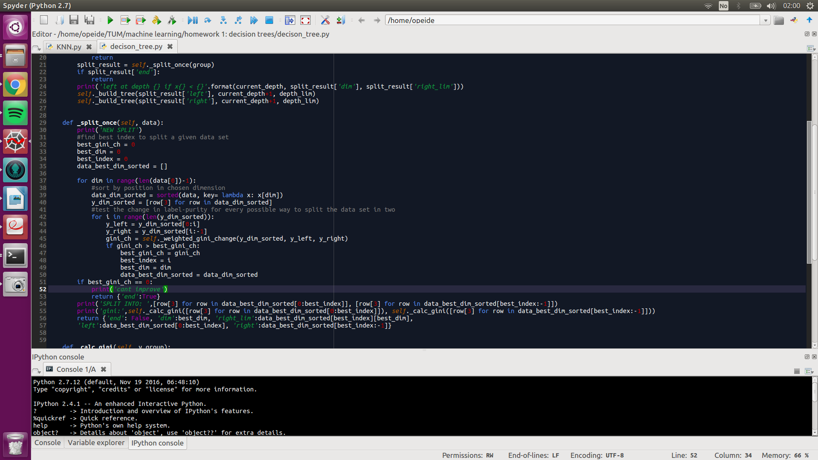

Code for task 4 and 5:
